Chapter 13, Problem 95.

Ten bulbs in parallel are supplied by a 7200/120-V transformer as shown in
Fig. 13.145, where the bulbs are modeled by the 144-Ω resistors. Find:

(a) the turns ratio n,

(b) the current through the primary winding.

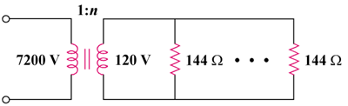

Figure 13.145
For Prob. 13.95.

